St. Irenaeus Ministry for Adult Faith Study
Calendar Syllabus

Location: St. Ann DC, 4001 Yuma St NW, Washington, DC 20016, Malta Library
Class Registration: stanndc.org/irenaeus Time: 6:30pm, Tuesdays

October 7, 2025 | Lecture 1– From Jesus to the Creation of the Church
October 14, 2025 | Lecture 2 & 3 – The First Christian Institutions & Christianities in the Early Church
October 21, 2025 | Lecture 4 – Persecution and Saints
October 28, 2025 | Lecture 5 & 6 – Peace Between Empire and Church & Institutional and Doctrinal Developments
November 4, 2025 | Lecture 7 – Latin Theology, Including Augustine
November 11, 2025 | Lecture 8 – Popes and Bishops in the Early Middle Ages
November 18, 2025 | Lecture 9 & 10 – Monasticism – Benedict and His Rule & Evangelizing Northern and Eastern Europe
November 25, 2025 | Thanksgiving Week – NO CLASS
December 2., 2025 | Lecture 11 – The Germanization of Christianity
December 9, 2025 | Lecture 12 & 13 – Charlemagne and the Church in Feudal Times & Monks and Hermits – New Forms of Monasticism
December 16, 2025 | Lecture 14 – Papal Reform and Church–State Controversies
December 23 and 30, 2025 | Christmas Break – NO CLASSES
January 6, 2026 | Lecture 15 – Crusade, Heresy, Inquisition
January 13, 2026 | Lecture 16 & 17 – The Papacy – Innocent III to Boniface VIII & Francis, Dominic, and the Mendicants
January 20, 2026 | Lecture 18 – Flowering of Church Art in the Middle Ages
January 27, 2026 | Lecture 19 – Scholastic Thought
February 3, 2026 | Lecture 20 & 21 – Medieval Mysticism & The Great Schism and the Conciliar Age
February 10, 2026 | Lecture 22 – The Renaissance Church
February 17, 2026 | Lecture 23 – Luther, Calvin, and the Reformation
February 24, 2026 | Lecture 24 – Catholic Responses – The Council of Trent
March 3, 2026 | Lecture 25 & 26 – The Jesuits & Catholicism in Asia and the New World
March 10, 2026 | Lecture 27 – American Catholicism
March 17, 2026 | Lecture 28 – The Church in the Age of Reasons
March 24, 2026 | Lecture 29 & 30 – Pius IX and Papal Infallibility & Leo XIII and the Modern World
March 31, 2026 | Lecture 31 – The Eastern Catholic Churches
April 7, 2026 | Lecture 32 – The Second Vatican Council
April 14, 2026 | Lecture 33 & 34 – The Catholic Church Looks Outward & The Challenges of New Theologies
April 21, 2026 | Lecture 35 – John Paul II and the 21st-Century Church
April 28, 2026 | Lecture 36 – One? Holy? Catholic? Apostolic?
May 5, 2026 | End-of-Year Event

Thank you for joining our Study!
Stay connected with us:
God bless you.
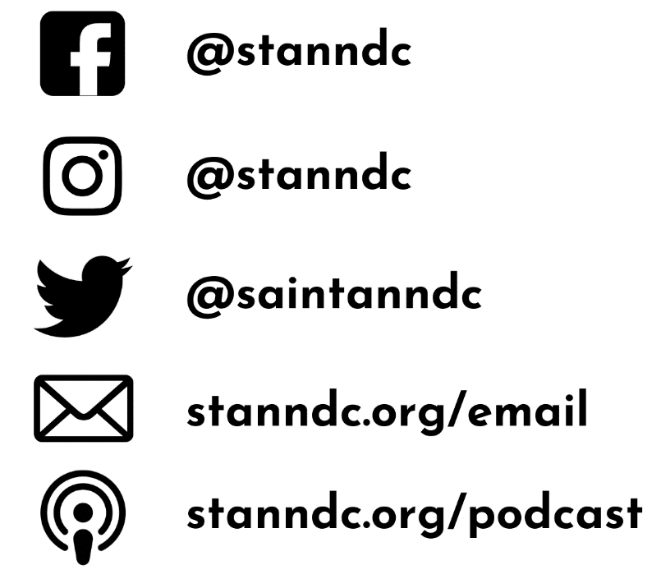

Come to Mass on Sundays! – Weekends Masses are Saturdays at 5pm, and Sundays at 7:30am, 11:00am and 7:00pm. Special Mass times can be found at stanndc.org/mass

REGISTER as a Member of Our Parish! – Visit stanndc.org/register to become a member of St. Ann!

Learn about Your Church - The most up-to-date info, news and events can be found on our website here: stanndc.org Grab a bulletin when you visit us! If you forget, find them here: stanndc.org/bulletins
Never Miss a Homily - If you have always wanted to share what you hear on Sundays, or if you’re out of town for a weekend, find the homilies published weekly, right here: stanndc.org/podcast

